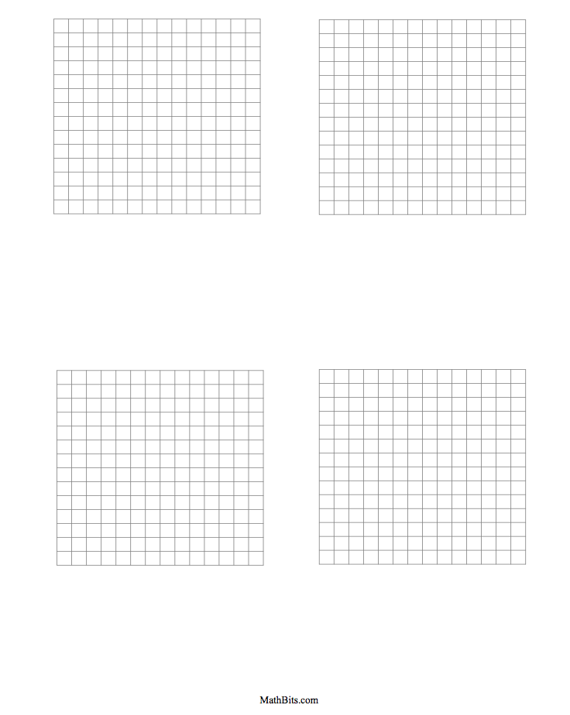

Some where around 43

Some Where around 55

Some where around 28

= 1 cm2

= 1 cm2

= 1 cm2

= 1 cm2